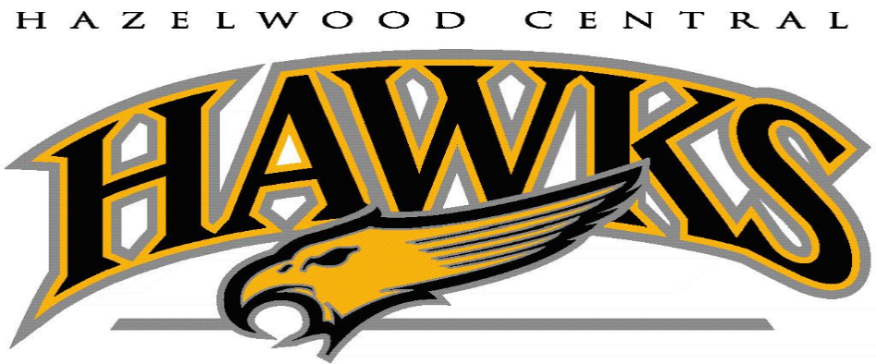

Performance Schedule

2021-2022

October 14-16 Fall Play 7:00 pm

October 28 Orchestra Halloween Concert 7:00 pm

November 11 Veterans Day Band Concert 7:00 pm

December 2-4 Winter Play 7:00 pm

December 7 Orchestra Concert 7:00 pm

December 16 Choir Concert 7:00 pm

March 8 TRI-M Concert 7:00pm

May 12-14 Musical 7:00 pm

May 17 Band/Orchestra Concert 7:00 pm

May 17 Theatre Gala 7:00pm

May 19 Choir Concert 7:00 pm

May 24 Elementary Band/Orchestra Concert 7:00 pm